Botany Annual Report, 2023 Recorder John Rodgers

The year began, as in the recent past, with a New Year Plant Hunt, a nationwide event run by the Botanical Society of Britain and Ireland ( BSBI ). Seven people took part and identified 26 species. Last year’s foray produced 28 species. The commonest were Daisy ( Bellis perennis ) Dandelion ( Taraxacum agg) and Groundsel ( Senecio vulgaris ). These all came from the streets of Oakham and Uppingham.
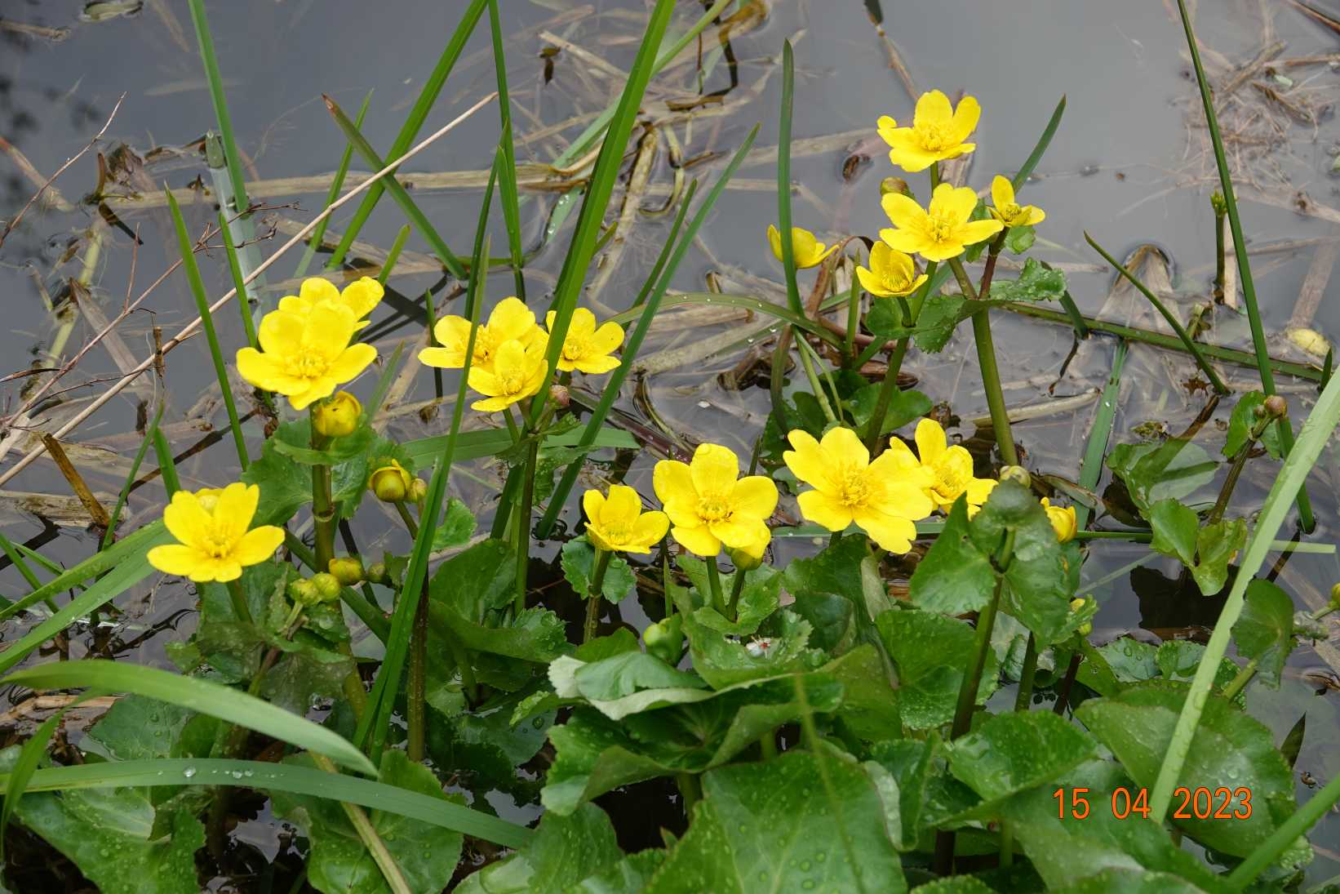

In the year as a whole 577 species were recorded by 17 recorders. There were Society visits, with botany in mind, to Merry’s Meadows, Launde Big Wood, Panter’s Orchard and Hebe’s Wood and, outside Rutland, to Collyweston Quarries and Stonesby Quarry. In Merry’s Meadows 19164 spikes of Green-winged Orchid ( Orchis morio) were counted on the whole reserve, 15360 in Cow Pastures, the first field. This is the highest number recorded for some years. Hebe”s Wood yielded Common Spotted ( Dactylorhiza fuschii) and Southern Marsh Orchid ( Dactylorhiza praetermissa ) whilst there were Bee Orchids ( Ophris apifera )in Bloody Oaks Quarry and Ketton Quarry. For the first time they were also found in the grass verge on Pitts Lane opposite one of the entrances to the reserve. Another first was Pyramidal Orchids ( Anacamptis pyramidalis ) on the verge of the Oakham bypass.

Early in the year Steve Woodward found a rosette of leaves on a “green” at Essendine which he thought belonged to an unusual Salvia. The County Council agreed to make sure the area was not mowed and a local resident also protected the plant which proved to be Wild Clary ( Salvia verbeneca ) when it flowered. This is an unusual plant only found in three or four sites in Leicestershire and Rutland. Very soon after this, specimens of the same plant were found on the roadside in Great Casterton ! A sudden flourishing ! Another member of the same family was found near Leighfield. This is Wood Sage ( Teucrium scorodonia ) which occurs in the west of Leicestershire but which is uncommon in Rutland.

As always we must thank all those who submitted records. Their work is vital to our understanding of the botanical diversity of the county and how it changes over time.

